WATP Physics Stage 2: Formulae and Constants Sheet

Area of Study: Motion and Forces
Average velocity | 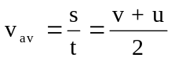
Equations of motion | 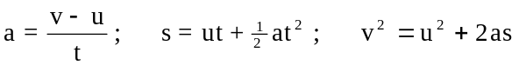
Force | 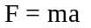
Weight Force | F_{weight} = mg
Momentum | 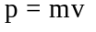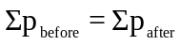
Change in momentum (Impulse) | F.Δt = Δp = mv - mu
Kinetic energy | 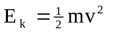
Gravitational potential energy | 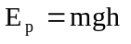
Work done | W = Fs = ΔE
Power | 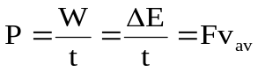
Mean acceleration due to gravity on Earth | g = 9.80 m s⁻²
Tonne | 1 tonne = 10³ kg = 10⁶ g

Area of Study: Nuclear Physics
Activity | 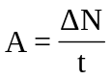
Half-life | 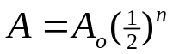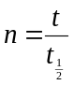
Absorbed Dose | 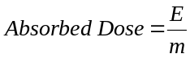
Dose Equivalent | Dose Equivalent = Absorbed Dose × Quality Factor
Mass-energy relationship | E = mc²
Speed of light in a vacuum or air | c = 3.00 x 10⁸ m s⁻¹
a.m.u – energy equivalence | 1 u = 931 MeV
Electron volt | 1 eV = 1.60 × 10⁻¹⁹ J
Mega electron volt | 1 MeV = 1.60 × 10⁻¹³ J
Unified atomic mass unit | 1 u = 1.66 × 10⁻²⁷ kg

Weighting Factors
Radiation Type | Approximate Quality Factor
Gamma Ray | 1
Beta Particle | 1
Slow Neutron | 3
Fast Neutron | 10
Alpha Particle | 20

Table of Nuclear Rest Masses (note - masses of nuclei do not include atomic electrons)

Particle | Mass (u) | Mass (kg)
Electron/positron | 0.000549 | 9.11 × 10⁻³¹
Proton/hydrogen | 1.00728 | 1.6726 × 10⁻²⁷
Neutron | 1.00867 | 1.6750 × 10⁻²⁷
Deuterium (H-2)  Tritium (H-3) | 2.013553  3.015501 | 3.34358 × 10⁻²⁷  5.00736 × 10⁻²⁷
Helium-3  Helium-4 | 3.014932  4.001506 | 5.00641 x 10⁻²⁷  6.64466 × 10⁻²⁷
Carbon-12 | 11.996709 | 1.99210 × 10⁻²⁶
Carbon-14 | 13.999951 | 2.32475 × 10⁻²⁶
Krypton-92 | 91.906404 | 1.52614 × 10⁻²⁵
Barium-141 | 140.883686 | 2.33943 × 10⁻²⁵
Neptunium–237 | 236.997149 | 3.93543 × 10⁻²⁵
Thorium-234 | 233.994223 | 3.88556 × 10⁻²⁵
Uranium-235 | 234.993454 | 3.90216 × 10⁻²⁵
Uranium-238 | 238.000313 | 3.95209 × 10⁻²⁵
Plutonium-239 | 239.000590 | 3.96870 × 10⁻²⁵
Americium-241 | 241.004708 | 4.00198 ×10⁻²⁵

Area of Study: Heating and Cooling
Heat (Q), involved in a temperature change | 
Heat (Q) involved in a phase change | 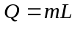
Absolute zero of temperature | 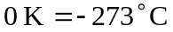
Power | 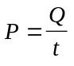

Specific Heat Capacity of selected substances
Substance |  | c (J kg⁻¹ K⁻¹) | Metals |  | c (J kg⁻ ¹K⁻¹)
 | Water | 4.18 × 10³ |  | Aluminium | 9.00 × 10²
 | Ice | 2.10 × 10³ |  | Steel (Stainless) | 4.45 × 10²
 | Steam | 2.00 × 10³ |  | Lead | 1.26 × 10²
 | Glass | 8.40 × 10² |  | Copper | 3.80 × 10²
 | Wood | 1.70 × 10³ |  | Mercury | 1.40 × 10²
 | Air | 1.00 × 10³ |  | Silver | 2.37 × 10²
 | Human body (Av) | 3.47 × 10³ |  | Pewter | 1.43 × 10²
 | Ethanol | 2.40 × 10³ |  | Uranium | 1.16 × 10²

Latent Heat of selected substances
Material | Phase change | Value (J kg⁻¹)
Ice (H₂O) | Fusion | 3.34 × 10⁵
Steam (H₂O) | Vaporisation | 2.26 × 10⁶
Silver | Fusion | 1.03 × 10⁵
Lead | Fusion | 2.50 × 10⁴
Ethanol | Fusion | 1.65 × 10⁵

Melting points and boiling points
Material | Melting Point (ºC) | Boiling Point (ºC)
Water | 0 | 100
Carbon disulfide | -112 | 46
Ethanol | -114 | 78
Chloroform (trichloromethane) | -64 | 62
Tungsten (W) | 3410 | 5900
Silver (Ag) | 961 | 2193
Aluminium (Al) | 660 | 2519
Copper (Cu) | 1085 | 2562
Lead (Pb) | 327 | 1750

Area of Study: Electrical Fundamentals
Electric current | 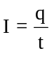
Work and Energy | 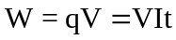
Ohm’s law | V = IR
Resistance in Series | 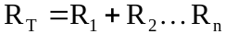
Resistance in Parallel | 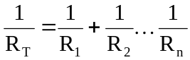
Power | 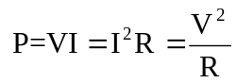
Electron charge | q_{e} = -1.60 × 10⁻¹⁹ C

Electromagnetic spectrum (N.B. approximate guide only)

 | Wavelength
λ (m) |  | 10² |  | 10 |  | 1 |  | 10⁻¹ |  | 10⁻² |  | 10⁻³ |  |  |  | 10⁻⁴ |  | 10⁻⁵ |  | 10⁻⁶ |  | 10⁻⁷ |  | 10⁻⁸ |  |  | 10⁻⁹ |  |  |  | 10⁻¹⁰ |  |  |  |  | 10⁻¹¹
microwaves
radio frequencies
infrared radiation
ultraviolet
radiation
X-rays
gamma rays


Area of
Spectrum
f(Hz) | 10⁶ |  | 10⁷ |  | 10⁸ |  | 10⁹ |  | 10¹⁰ |  | 10¹¹ |  |  | 10¹² |  |  | 10¹³ |  | 10¹⁴ |  | 10¹⁵ |  | 10¹⁶ |  | 10¹⁷ |  |  |  |  | 10¹⁸ |  |  |  | 10¹⁹ |  |  |  |  | 10²⁰
 | Frequency

Note: 1. Shaded areas represent regions of overlap. 2. Gamma rays and X-rays occupy a common region.
3. Visible limit for red light at 750 nm and visible limit for violet light at 400 nm

Mathematical expressions
B
c
a
Given ax² + bx + c = 0, 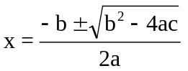
b
A
C

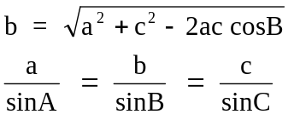

Prefixes of the Metric System
Factor | Prefix | Symbol | Factor | Prefix | Symbol
10¹²  10⁹  10⁶  10³ | tera  giga  mega  kilo | T  G  M  k | 10⁻²  10⁻³  10⁻⁶  10⁻⁹ | centi  milli  micro  nano | c  m  µ  n

